**Pre-AP Chemistry – Unit 3 – Atomic Structure and the Nature of Electrons**

*Objective 1: Students will explain the development of atomic theory from Dalton to the quantum model. [AT.1.C.1, AT.1.C.2]*

1. Explain the problems with Dalton’s Modern Atomic Theory.

The first problem with Dalton’s theory is that atoms are divisible, as proven by Thomson, Rutherford, and Chadwick. The second problem is that not all atoms of an element have the same mass…the discovery of isotopes has proven this.

1. Explain how Thomson and Rutherford used their experimental results to arrive at their models.

Thomson used the idea that cathode rays were deflected by an electric field to deduce that they have a charge and the fact that they are deflected by magnets to prove they have magnetism. Since both of these things are properties of matter he correctly deduced that cathode rays are a beam of particles, not energy. He then postulated that the electrons must be offset by some positive charge and set forth the plumb pudding model to show this. Rutherford’s observations led to his advancement in the following ways: most of the α’s were deflected meaning an atom is mostly empty space; some α’s were deflected meaning there are centers of positive only charge in an atom; and some α’s were reflected nearly straight back meaning there were dense areas in the atom where most of the mass was located. These three ideas, taken together, were the basis of his nuclear model of the atom.

1. What important piece of information was obtained in the Millikan oil drop experiment?

The experiment measured the charge of a single electron. As a bonus the mass of a single electron was also calculated.

1. What significant piece of information was discovered by Chadwick?

The existence of neutrons.

1. Describe the revolutionary idea postulated by Planck to explain his experimental observations concerning black-body radiation.

He was the first to describe electromagnetic energy as being quantized, meaning it was only delivered in packets called photons with specific chunks of energy called quanta. His constant, *h*, relates the energy of a quantum to the frequency of the radiation through the equation E = hυ.

1. Briefly explain how Bohr used Planck’s ideas to postulate his model of the hydrogen atom.

Bohr postulated that electrons orbit a nucleus much like planets orbit the sun. He set the orbits equal to energies that he said corresponded to “allowed states”, or states where the electron could orbit without losing energy and crashing into the nucleus. Thus he used Planck’s idea of quantized energy to explain how and why electrons should adopt the orbits he described.

1. What has to occur, according to Bohr, for an electron to transition from one energy level to another?

The electron has to either gain (to move to a higher energy level) or release (to fall to a lower energy level) the exact energy difference between the two levels it is moving between. This energy is called a quantum, and is related to the frequency of the radiation absorbed or emitted through the equation E = hυ.

1. Name the atomic model associated with Schrödinger. Briefly explain how it is different than Bohr’s model and why this was a necessary adjustment.

The quantum model is associated with Schrödinger. Instead of fixing orbit radius, like Bohr, Schrödinger fixed the energy of an electron. This was necessary because electrons move as a wave in three dimensions and not in two dimensions as you might imagine a large object, like a planet. This allows for the determination of the energy but not the exact position of the electron, which is preferable. According to Heisenberg, we can’t know both exact position and energy at the same time for a particle behaving as a wave.

*Objective 2: Students will describe the location of subatomic particles and the forces that bind them. [AT.2.C.1, AT.2.C.2]*

1. Which subatomic particle defines identity and which defines reactivity?

Proton = identity, electron = reactivity

1. What force(s) hold a nucleus together? What force(s) attract electrons to it? Which is stronger? What easily observable, naturally occurring phenomenon supports the strength argument?

The strong force binds a nucleus while electrostatic attraction holds electrons to the nucleus. The strong force is a greater attraction. This is evidenced by the fact that all chemical reactions involve movement of electrons between atoms, but only nuclear decay processes involve the degeneration of the nucleus.

1. Draw a simple diagram of an atom and indicate the location and charge of each type of subatomic particle discussed in class. Use the appropriate symbols to identify the particles.



1. Briefly explain why the particles are constrained to the locations indicated in your diagram from question three.

Protons and neutrons are in the nucleus because they are the particles with mass and experiments have shown the mass of the atom is centrally located. The positive charge is located away from the negative charge due to the observation that charged particles are deflected when fired through a film of atoms…since protons are in the nucleus it has a positive charge. The electrons cannot be there, so they are located “somewhere outside” the nucleus.

*Objective 3: Students will differentiate and fully describe isotopes of elements, including average atomic mass, isotopic mass, and isotopic symbol. [AT.2.C.3, AT.2.C.4, AT.2.C.5]*

1. Define the following terms: atomic number, mass number, average atomic mass, atomic mass unit.

Atomic number – number of protons in the nucleus of an atom

Mass number – combined number of protons and neutrons in the nucleus of an atom

Average atomic mass – the weighted average mass of all isotopes of an element

Atomic mass unit – 1/12 the mass of a carbon-12 atom.

1. Give the number of each of the subatomic particles in gallium-71.

31 protons, 31 electrons, 40 neutrons

1. Explain, in detail, how you can tell the following two atoms are isotopes: ${}_{7}^{14}X$ and ${}_{7}^{12}X$.

They have the same number of protons indicated in the isotopic symbols.

1. Explain how to calculate the average mass of a naturally occurring element.

You determine the identity and natural abundance of each isotope. Then, measure the mass of each isotope. Finally, multiply each isotope mass by its natural abundance (expressed as a decimal) and sum up the pieces.

1. Calculate the average atomic mass of an element, X, that has the following isotopes: X-102 (65.2%, 102.01amu), X-98 (31.2%, 97.99amu), and X-105 (3.60%, 105.00amu).

101 amu

1. Calculate the percent abundance of Zirconium-93 and Zirconium 90. The average mass of Zirconium is 91.22 amu.

41% zirconium-93 and 59% zirconium-90

*Objective 4: Students will write electron configurations for atoms and ions as well as calculate the energies and wavelengths associated with electron transitions. [AT.3.C.1, AT.3.C.2, AT3.C.3, AT.3.C.4]*

1. Define the following: Aufbau principle, Hund’s rule, Pauli exclusion principle, electron configuration, orbital configuration, pseudo noble gas configuration, photon.

See a dictionary.

1. A red laser has a wavelength of 696 nm. What is the energy of the laser beam? What is the frequency?

E = hc / λ = ( 6.62610−34Js)(3108m/s) / (69610−9m) = 2.8610−19J

υ=E / h = 2.8610−19J / 6.62610−34Js = 4.311014Hz

1. If an electron drops from an energy level with E1 = 3.23  10−19J to a level where E2 = 9.1  10−20 J what would be the wavelength of the emitted radiation?

Ephoton = E1 – E2 = 3.2310−19J – 9.110−20J = 2.3210−19J

λ = hc / E = (6.62610−34Js)(3108m/s) / (2.3210−19J) = 8.5710−7m

1. Using a diagram, show two different Bohr electron transitions and state which transition releases light of greater energy.

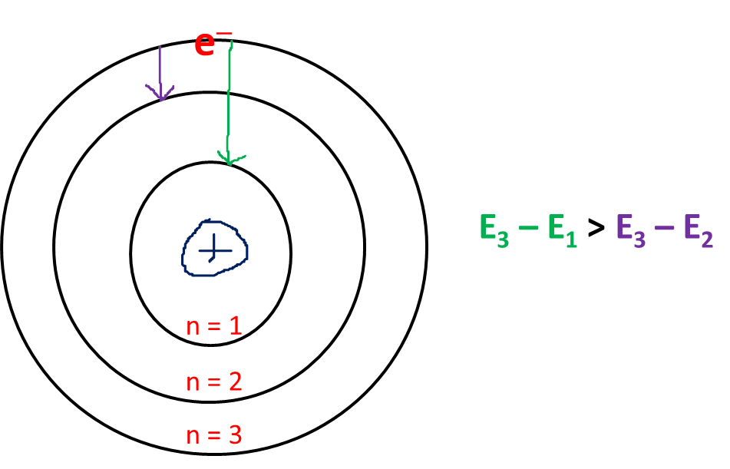

1. Write electron configurations for the following: sodium, iodine, nitrogen, aluminum cation, fluoride ion, iron(II) ion.

Na: 1s22s22p63s1 N: 1s22s22p3 Al3+: 1s22s22p6 F1−: 1s22s22p6

Fe2+:1s22s22p63s23p63d6

1. Write orbital electron configurations for the following: oxygen and manganese.

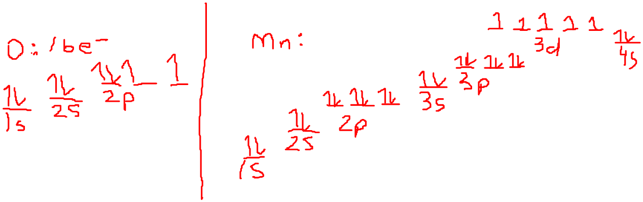

1. Define each of the four quantum numbers and tell what each value describes about an electron.

Look in your notes…we wrote this exact information down!