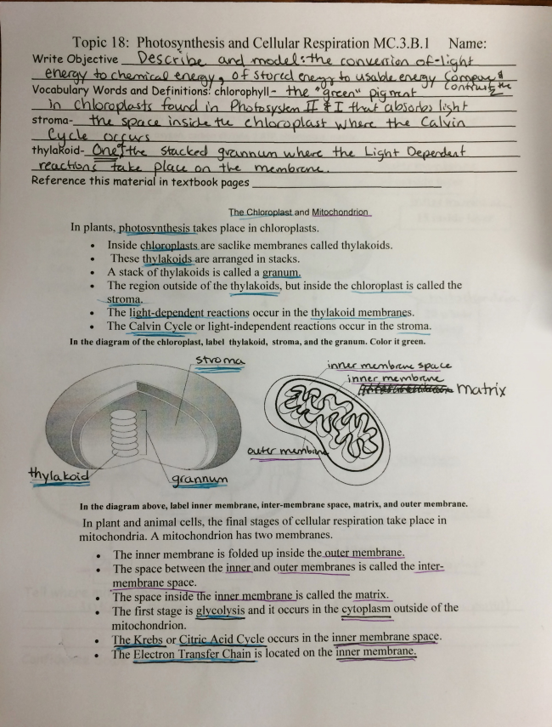
Topic 18: Rhotosìfnthesis and Cellular Respiration MC.3.B.1 Name:
Wr'ife ObjecTive
De
TheßhlomplasLand M_inghQnam
In plants, photosynggesis takes place in chloroplasts.
Inside çhjggplastsìare saelike membranes called thylakoids.
These thquëgmjgsäare arranged in stacks.
A stack of thylakoids is called a granum.
T1@ reactions occur in the jngylakqigzrgçlllbranes.
The Calvin1 _Quia 0r light-independent reactions Occur in the stroma.
ln the diagram of the chloroplast, label thylakoid, stroma, and the granum. Color it green.
ln the diagram above, label inner membrane, inter-membrane space, matrix, and outer membrane.
ln plant and animal cells, the final stages of cellular respiration take place in mitochondria. A mitochondrion has two membranes.
The inner membrane is folded up inside theßulemm
The space between the _inner and Quter membranes is called the inter
membrane s ace. The mace inside t
'ile space im@ innermßmllëlßlis Called the matrix.
The first Stage ÍS ggg/:Sig and it occurs in the cytoplasm Outside ofthe mitochondrion.
Theißgebs or Citrgé' Y cid Cïcle occurs in the inner membrane sgace.
The Electren Trgnßïpgain is located 0n the 'inner membrane.

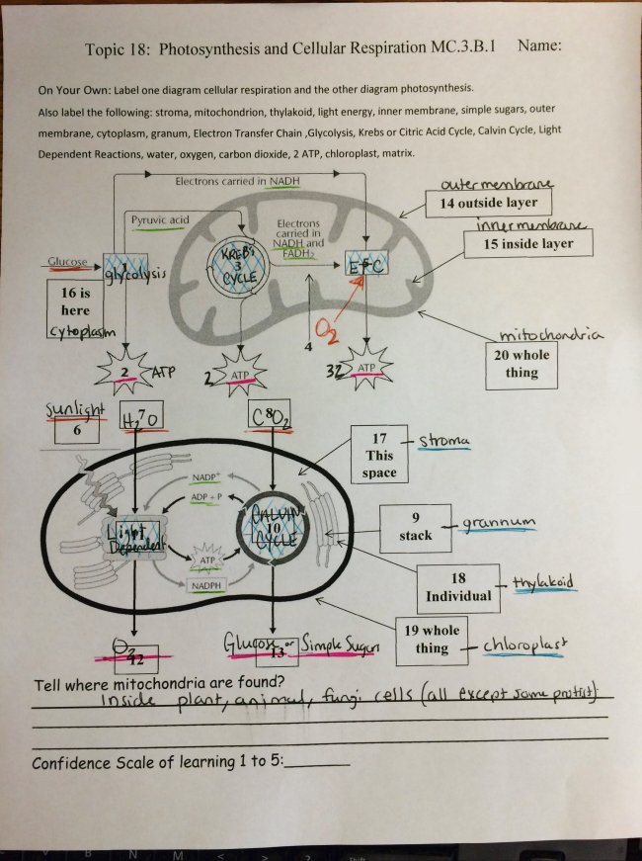
Topic 18: Photosynthesis and Cellular Respiration MC.3.B.l Name:
On Your Own: Label one diagram cellular respiration and the other diagram photosynthesis.
Also label the following: stroma, mitochondrion, thylakoid, light energy, inner membrane, simple sugars, outer
membrane, cytoplasm, granum, Electron Transfer Chain ,Glycolysìs, Krebs or Citric Acid Cycle, Calvin Cycle, Light
Dependent Reactions, water, oxygen, carbon dioxide, 2 ATP, chloroplast, matrix.
’_
Eleftmns Garges! in NADH
UDM
mmm 14 outside layer
m
15 inside layer
Confidence Scale of learning 1 To 51

